Williams Lake
HOA Annual Newsletter
2025
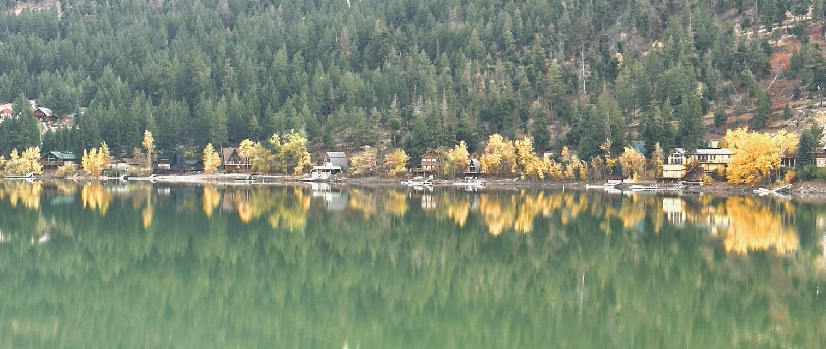
Photo Credit: Jill Chapman

Table of Contents
A Letter from the President…..3
The year in Review…..4
In Memoriam…..5
Activities…..6
Roads Commissioner…..7
Treasurer…...8
Water and Sewer…..10

2025 Annual Meeting:
Saturday, July 5, 2025, at 10am

Your William’s Lake HOA Officers:
President*: Rich Franken
Vice President: Tom Buker
Vice President: Gary VanVorce
Roads Commissioner: Corky Robinson
Treasurer: Anne Franken
Secretary: Holly Roach
Volunteer Fire Chief: OPEN

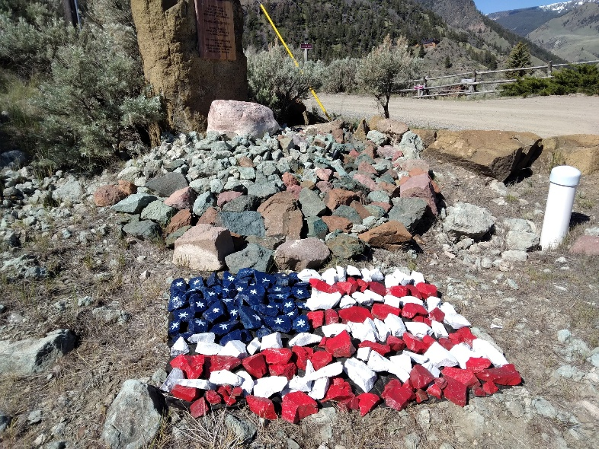
Thank you, Cathy Ennis, for this beautiful rock display!

*President position will be open next year.
A Letter from the President
Greetings Everyone!

I hope you are all doing well. We are looking forward to another great summer at Williams Lake.

Most of you are aware that we had 2 severe fires this past summer, the Thunder Fire in July and the Red Rock Fire in August. We were placed in "set" status twice and it was quite unsettling for all here at that time. I am sure I do not need to remind you that fire danger remains high in this area. Please be vigilant of your property and your neighbors. Please trim your trees, bushes, weeds and you can put them in burn pile near the trash containers. Be sure no nails, etc. just brush. As a reminder, the Lemhi County Dump is free for your brush, etc.

Our Fire Station has a great new look with special thanks to Kyle Jacobs for his work on it over the winter months. The entire building is now covered with metal for a long-lasting look and minimal repairs for future needs. Our plan will be to complete this necessary upgrade/repair with some Trex decking and new steps and new ramp.

A big thank you to Llee Chapman for contacting the Sheriff's Department and installing new buoys on the lake. This will ensure safety for our lakefront residences and water safety.

A special thank you to Mark Moore, who helped some of our yearly residences who were without water for a few weeks. We did not have much snowpack this year, which caused deep freezing for those pipes on the Northside which are not as deeply buried due to all the rock in that area. He has made recommendations to the Water Board to see if we can make some adjustments and avoid another freeze for the future.

Aluminum cans are still being collected by the trash bins, I will continue to take down the hill for the Ronald McDonald House donations.

Enjoy the 4th of July Festivities and try to attend some of the get togethers being planned by our Event Coordinator, Kim Blum.

I look forward to seeing you all.
Rich Franken
The Year in Review
Last summer we were threatened by the Thunder Fire which started via lightening and burns approx. 2,474 acres through August. Shortly after that was out the Red Rock Fire started. Photo credit: Anne Franken
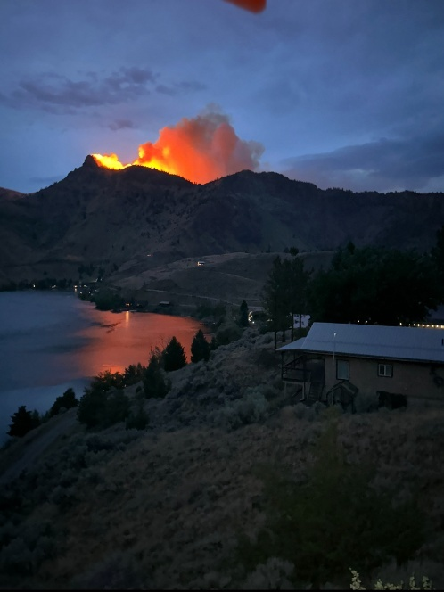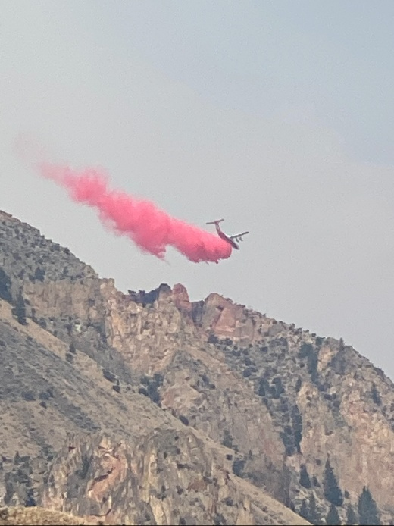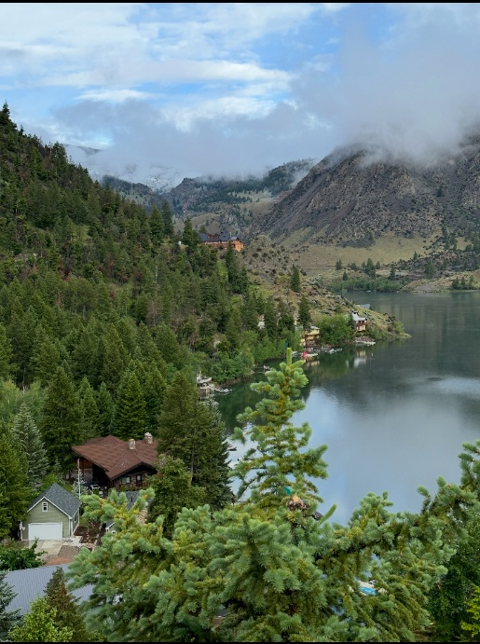
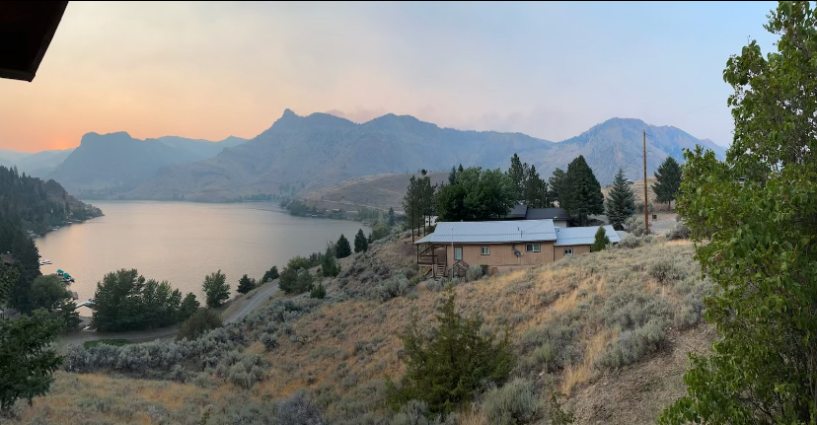
In Memoriam

Layne Scholkowfsky
6/16/55-2/25/25

Kathy Glicksman
9/13/40-2/26/24

Leslie Shumate
11/15/42-3/20/24
Activities Update
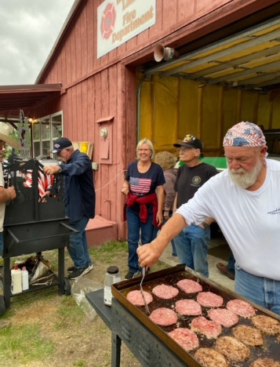
Welcome back Williams Lake Family 2025…
There are a couple of places that we will post all events taking place here at Williams Lake and in Salmon Idaho.
The first one is the calendar that will be hanging in the Firehouse with upcoming events. The other one is a big 4-foot-wide erase board that you could see when you pull into Williams Lake.
On Friday, the 4th of July, the HOA will be sponsoring a barbecue at the firehouse at 6 PM eating time.
Hamburger and hotdog and all the trimmings will be provided by HOA. Please bring a side dish to share and have it there no later than 5:45pm
Bring your own beverage
We are doing a breakfast potluck at the homeowners associating meeting at 10 AM on Saturday, July 5th.
Please bring your favorite breakfast dish to share.
We will be continuing to hold chair, yoga classes on Tuesdays and Thursdays at 10 AM.
We will post on the white erase boards when we will be having bunco, bingo, and left right center games.
See you all soon,
Kim

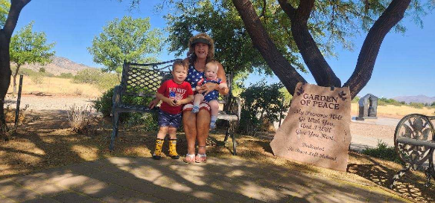
Road Update

Hello, Williams Lake Homeowners, I’m really looking forward to another beautiful season at, “Our Happy Place”.
The road maintenance this year will begin in June and most likely run to July. Remember, as homeowners we are all responsible for the roads and their condition so let’s keep them nice. It depends on us all to be respectful of the land and people who live and visit Williams Lake. Please drive safely and let us all enjoy another fun and safe year at the lake!
Corky Robinson
Williams Lake Roads Commissioner

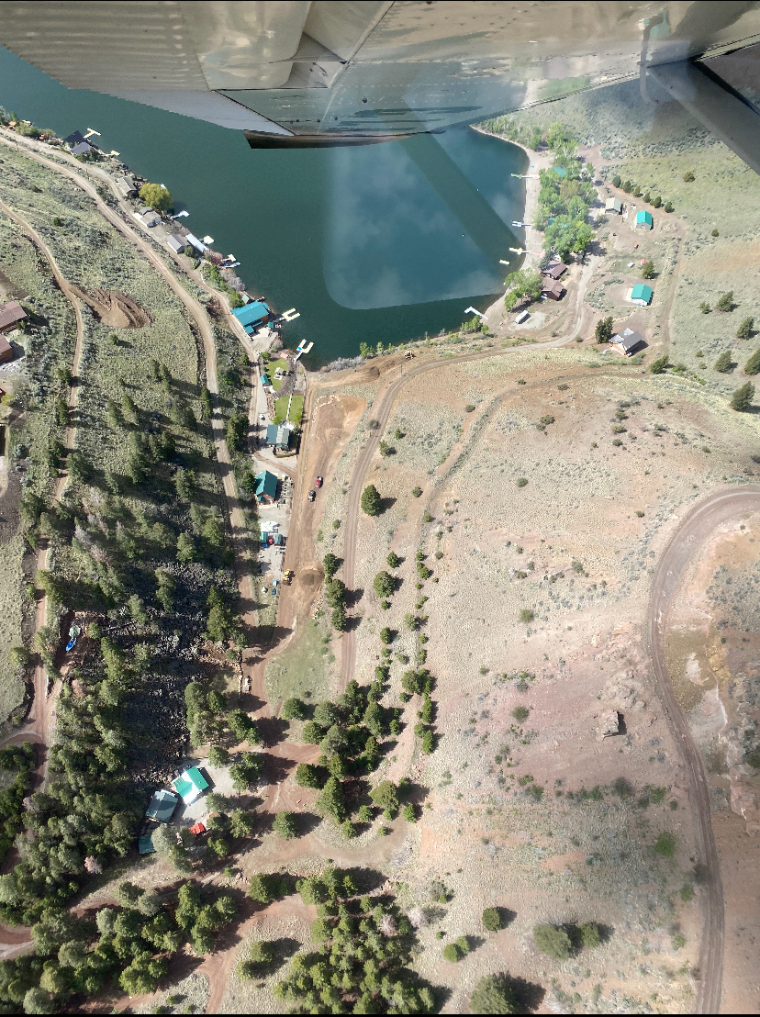
Treasurers Update

Our 2024 Annual meeting increased home and lot owner dues. This has caused a bit more work in explaining to those not in attendance at our meeting, however, most are very agreeable upon hearing the explanation. I would like to stress the importance of our annual meeting and if you are unable to attend, please note that the newsletter and the minutes from all meetings are posted on the website at www.williamslakeidaho.com The website is a great tool for both the HOA and the Water Board.

We changed everything over to Starlink from CenturyLink and what a success in comparison. We are saving about $30/monthly with this change. Our trash fees remain down since we have added the extra dumpster. Administrative costs are only the Quickbooks software monthly expense plus postage used in mailing. Our Social budget contains our annual picnic and fireworks and some small bingo mixers. The utilities budget contains your trash, electricity and internet.

The Fire Truck spent its first winter without being winterized.... the heater and insulation were a success. The Lemhi County Fire Dept came up and checked out the Firehouse, truck and all of our roads. They recommended new reflective road signage in case of their need to respond. However, they are still understaffed and unable to include us in the district but gave us some valuable information. The BLM and Forest Service also have us on their schedule for 2026 to clear a fire break and the dead trees on the south and west sides of the lake.

We have had many lots sold this past year and the local title companies are contacting me for any outstanding HOA dues; we have been able to collect a significant portion of the old ones. I am now working on those who have moved and left no forwarding and/or those who are deceased and trying to locate relatives.

Thanks for paying your dues promptly. We are down to about 30 who have to be mailed versus email.... This is costing us currently 73 cents each... so please provide your email for billing!

Thanks,

Anne Franken

Williams Lake Homeowner’s Association Financials

 | Actual | PROJECTED BUDGET
Calendar Year | 2024-25 | 2025-26
Home and Lot Owner Dues | $21,670 | $45,410
Fire Donation / HOA donation | $2,250
Other Income
Total Income | $23,920 | $45,410
Administrative | $1,229 | $1,200
Fire Department | $7,661 | $3,500
Roads | $14,522 | $15,000
Social | $1,777 | $1,800
Utilities (Internet, Trash, Electrical, etc.) | $6,165 | $7,000
Weed Control | $1,694 | $1,700
Deck for Firehouse |  | $3,000
Total Expense | $33,048 | $33,200
Net Result |  | $12,210
HOA Fund Balance | $624
Emergency Fund Balance | $25,000
Current Account Balance - 6/15/25 | $25,624.15
Current Outstanding Dues for 2025 | $35,510
Outstanding Dues 2024 and prior | $13,100
Total Outstanding as of 6/15/25 | $48,610.00

Williams Lake Recreational Water and Sewer District
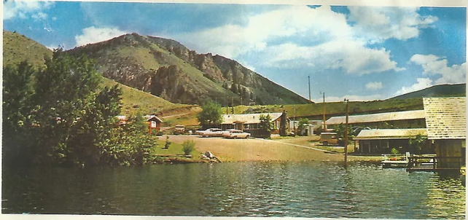
P.O. Box 82, Salmon, Idaho 83467

To: Williams Lake HOA Members 2024-2025 Summary

Dear Homeowners;

The Water Board as we are known has had a very busy year. First let me update you on our membership.

Board Members:
R. Llee Chapman, Chairman
Gary Mulkey, Treasurer
Craig Ammar
Tim Muir
Cathy Ennis

Support Team:
Anne Franken, Secretary
Mark Moore, Operations
Cory Rice, Wastewater and Water Licenses
Jared Bragg, Engineer

We began this fiscal and continue to fix up our system to ensure that you have a dependable water and sewer system. We would like to thank all of the homeowners for winterizing your homes, that really helps us keep the maintenance and the water usage in balance for the year. Also, thanks to all who have cleaned up your lots, the lake was looking great all year.

During this last year, we passed our budgets of $128,400 for the water system and $22,200 for the sewer system, paid the bills and kept things running. Currently we have the following fund balances:

Sewer System $11,800
Water System $287,800

We have 21 users on the sewer system, and they will pay an annual assessment of $300 for system use. As the rest of you are aware, your water system is paid for out of your property taxes.

During the year we have completed the backup power system to ensure that we will have water all year round. Our facilities plan is complete, and the next project will be the installation of a chlorination system. All Right of Ways and special use permits for the water tanks have also been updated. Water meters were insulated on Bayview in order to avoid freezing during the winter, this plan seems to be working well. Our main water line at Patterson’s to Froemming’s froze this year as the snows came very late. We will work to find a solution here. We may have to keep the valve open during the winter to keep water flowing. The pump system from the lake to the road will be operational this year. We have a 1,000-gallon tank so that we can move water around for our use as needed. Mark Moore will show any owners how to turn the system on and off so that you can feel free to use the system. Our telemetry system is still a work in process, it is coming along, we hope to get it completed this year.

The state completed a Sanitary Survey last year and we passed with flying colors. Thank you Mark for your great work.

The Water and Sewer System By-Laws have been updated and posted on the website. This document is intended to be living document, so please review and comment and we will continue to keep it updated.

Last year, we added a new water hookup on top of the hill for Casner’s. We expect several more to be added this year as most of the lots have been sold.

We are also discussing getting a backup for Mark Moore to be available to assist homeowners if Mark is not around. Kyle Jacobs has been a great help in this area, and we hope that he continues to be available to assist.

Last summer we worked on a portion of the sewer system that did not seem to function properly on the north side of the lake. This problem persisted into winter, we are currently trying several things to see if we can figure out what the problem and whether this situation may exist elsewhere on the lake. Once complete we will communicate with all homeowners.

We had a tough year as our great friends Layne Scholkowfsky and Leslie Shumate have passed away. Great friends are hard to come by so these losses are very near and dear to our hearts.

Both of these great people were good friends to the lake and to the Salmon area. RIP dear friends.

Cathy Ennis was elected to replace Layne on your water board. Welcome back Cathy, it is a pleasure to have you back. With Cathy coming back on the board, our membership is full, and we will not be having elections this year.

In summary, we have had a very busy year. I would like to thank all of the board members and support staff for all you do. Please feel free to contact any of us if you have questions or comments.

Thank you, See you at the Lake
Llee

